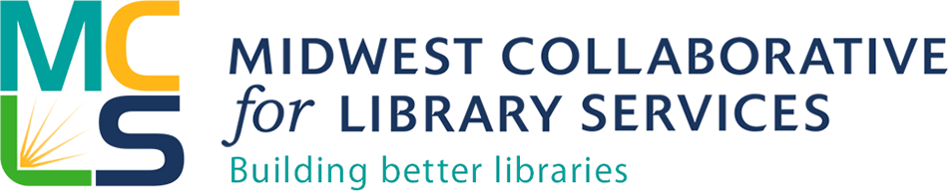
MCLS 2019 Indiana Harwood Cohort Application
Project: Application to attend the Indiana Library Staff Harwood Public Innovators Lab in Indianapolis, IN, March 5-7, 2019
Deadline: 5pm Eastern (4pm Central), November 30, 2018
Submit completed application by email to Michelle Bradley, Engagement, Consulting, and Training Manager, at bradleym@mcls.org
Funding Eligibility
- Applicants must work in an Indiana library that is an institutional member of MCLS.
- Applicants may be from any type of library: academic, public, school, institutional, or special.
- A minimum of 2 persons per library must be included in the application (up to a maximum of 5 persons per library)
  - The library director must be one of the applicants, or attest that they have previously attended a Harwood Public Innovators Lab.
  - Libraries are encouraged to include trustees or other community leaders as well.
  - Because of limited availability not all slots within an application may be filled.
- Libraries must submit proof of board of trustee support for the training and ensuing engagement work. This can be done by board resolution, evidence of support in your board meeting minutes, or by letter of support signed by your board of trustees.
- Libraries that have already sent staff to Harwood training and are looking for additional training will have equal consideration.

This project aims to build capacity within Indiana libraries to engage their communities.
*Save and name your application the name of your library.
Example: “Great Lakes Public Library Harwood Cohort application.doc”

What to include in your application:
Information about your library
- Name of Library:
- Address:
- Library Type (Public, Academic, School, Special, Institutional):
- Population Served:

Information about the applicant(s) seeking to attend the workshop and complete the follow-up training
- Name:
- Title:
- Email:
- Phone number:

- Name:
- Title:
- Email:
- Phone number:

- Name:
- Title:
- Email:
- Phone number:

- Name:
- Title:
- Email:
- Phone number:

- Name:
- Title:
- Email:
- Phone number:

Answer the following questions (Responses should be numbered in relation to the questions. In total, limit this response section of nine questions to 500 words.)
- How do you define your community? (local community, campus, school, etc.) Describe your community including geography, socioeconomic characteristics, ethno-cultural make up, and other relevant information.

- Describe where your library is in relation to community engagement, what you hope to achieve as a next step, and how being involved in this project will help your community.

- Describe the extent that your library is involved in formal partnerships and networking in your community, providing specific examples.

- Describe the top innovation that your library has led/implemented in the past two years.

- Describe why the Harwood Lab training and in-depth support from Harwood coaches is of interest to your library. What do you hope to accomplish with this support?

- Have you or other members of your library participated in any learning sessions of training in the Harwood Institute approach? If so, describe what you have done with what you learned so far. Please include successes, challenges, and any lessons learned to date.

- A major factor of success of the Harwood practice in your library will be engaged and supportive leadership and an accountability system. Please provide an explanation of how your library leaders will provide ongoing support for staff to a)implement the Harwood practice at your library, and b)participate in monthly in-depth coaching calls.

- How will the library’s leadership hold themselves accountable for implementing the Harwood practice?

- Is there anything else you would like us to know in support of your application?

Authorization
Authorizing Official Information
- Authorizing Official First Name:
- Authorizing Official Last Name:
- Email Address:
- Phone Number:
- Title:
- Organization:
- Certification—By checking this box and submitting this application, the authorized representative for the applicant organization certifies that all statements contained herein are true and correct to the best of their knowledge and belief. _____________
- By checking this box and submitting this application, the authorized representative for the applicant organization certifies that appropriate HR resources will be allocated to complete the training and engagement activities. _________
- By checking this box and submitting this application, the authorized representative certifies that the Library Director is either a) An applicant to attend the lab or b) Has previously attended a Harwood Public Innovator’s Lab.___________
- By checking this box and submitting this application, the authorized representative certifies that if selected for funding, they will submit a required final report. _______
The funds for this project are being made available through a grant program established by the MCLS Board of Directors from the proceeds of the sale of the former INCOLSA building.

